**PIXHAWK 4**

The advantages of using Pixhawk 4:

* Light weight
* Has 5V output which can be used for OEM1500 and its accessories
* The purchase came with kits.
* Prebuilt firmware using PX4 and QGroundcontrol
* Has a lot of resources which can be used to support our projects

Below is some documents and resources that we can use to learn more about Pixhawk 4.

About Pixhawk 4: <http://www.holybro.com/product/55>

Pixhawk 4: User’s guide: <https://docs.px4.io/en/flight_controller/pixhawk4.html>

Pixhawk 4: Flight Controller video introduction: <https://www.youtube.com/watch?v=nEMllpEfzv4>

<https://www.youtube.com/watch?v=IUX5FAI1pX4> << from SparkFun

Optimized to run PX4 ver. 1.7 ( or latest PX4 autopilot firmware) and QgroundControl.

PX4 User’s guide: <https://px4.io/user-guide-2/>

QGroundControl: <https://docs.qgroundcontrol.com/en/>

Pixhawk 4 Technical DataSheet: <https://github.com/PX4/px4_user_guide/raw/master/assets/flight_controller/pixhawk4/pixhawk4_technical_data_sheet.pdf>

Price: $211 (<https://shop.holybro.com/pixhawk-4beta-launch_p1089.html>) come with Pixhawk Kits.

Power supply

* Using 4.9 – 5.5 V power supply which is the same as OEM1500.
* Absolute max rating: 4.1 – 5.7V
* Not working but undamaged: 0 – 10V.

Weight: 15.8g

Dimension: 44x84x12mm

Assembly/Set up: <https://docs.px4.io/en/assembly/quick_start_pixhawk4.html>

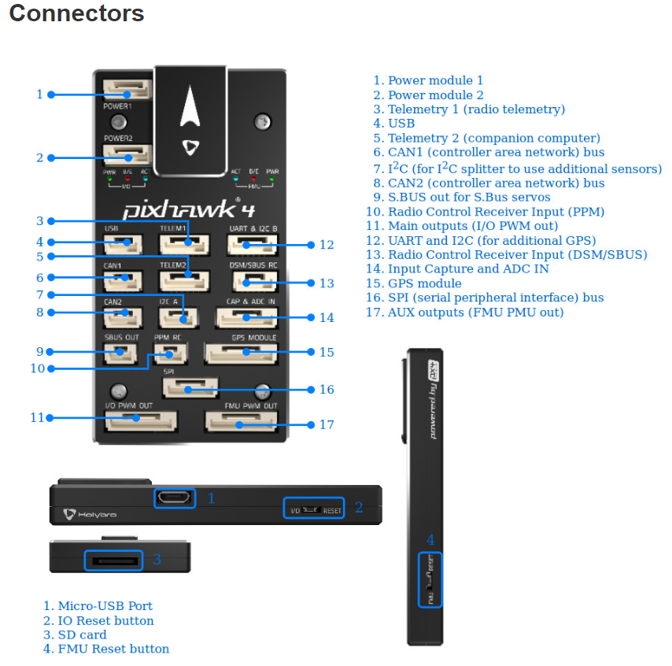

Pixhawk Pin Out Connectors: <http://www.holybro.com/manual/Pixhawk4-Pinouts.pdf>

**Total estimated hardware weight:**

1500 OEM + SOM: 7.13 g

1500 FPC: 2.23 g

FPC cable: 0.42 g

1514 cable: 4.70 g

Airbone camera: 7.44 g

Enclosure: 55.0 g (worst case)

5% estimation for nuts and screws: 5 g

Heatsink: 10.0 g

**Total:** 91 g

-----------------------------------------------------------------

Pixhawk 4: 15.8 g

Power board: 10.0 g

Lipo battery: 4.50 g

Cable: 20.0 g

**Total:**  90.8 g

The total first order estimated weight: 91 + 90.8 = 181.8 g

Therefore, the quadcopter must be able to carry about ~200g in weight.

**Building firmware:**

Most users will not need to build this firmware! It is pre-built and automatically installed by QGroundControl when appropriate hardware is connected.

Pre-built firmware with PX4-professional autopilot: <https://dev.px4.io/en/setup/building_px4.html>

QGroundControl: <https://docs.qgroundcontrol.com/en/>

QGroundControl provides full flight control and vehicle setup for PX4 or ArduPilot powered vehicles. It provides easy and straightforward usage for beginners, while still delivering high end feature support for experienced users.

**Key Features:**

* Full setup/configuration of ArduPilot and PX4 Pro powered vehicles.
* Flight support for vehicles running PX4 and ArduPilot (or any other autopilot that communicates using the MAVLink protocol).
* Mission planning for autonomous flight.
* Flight map display showing vehicle position, flight track, waypoints and vehicle instruments.
* Video streaming with instrument display overlays.
* Support for managing multiple vehicles.
* QGC runs on Windows, OS X, Linux platforms, iOS and Android devices.